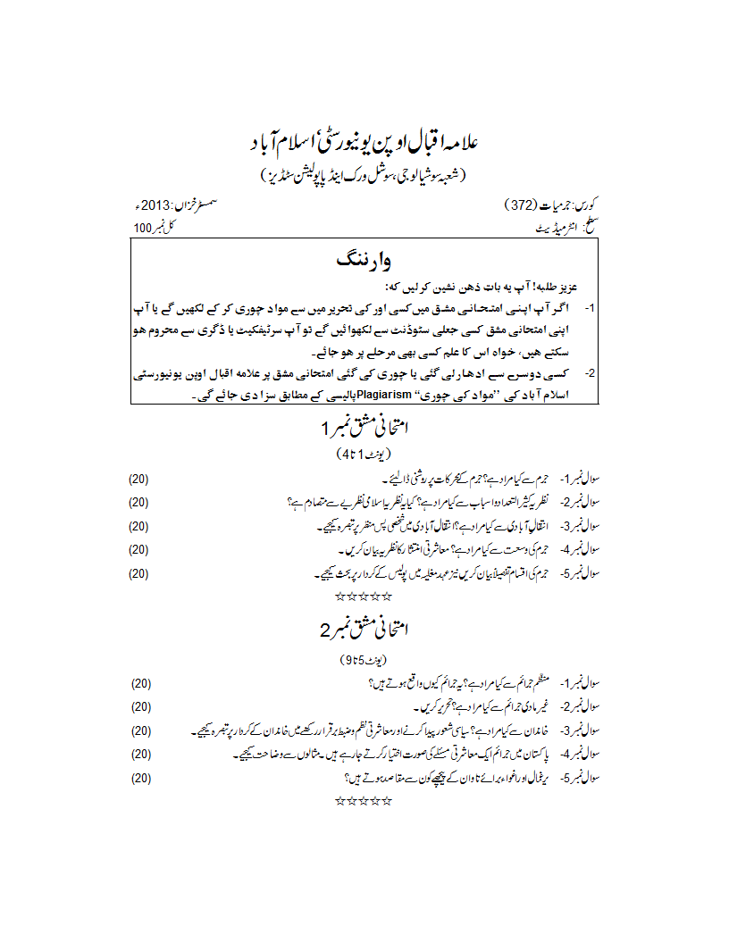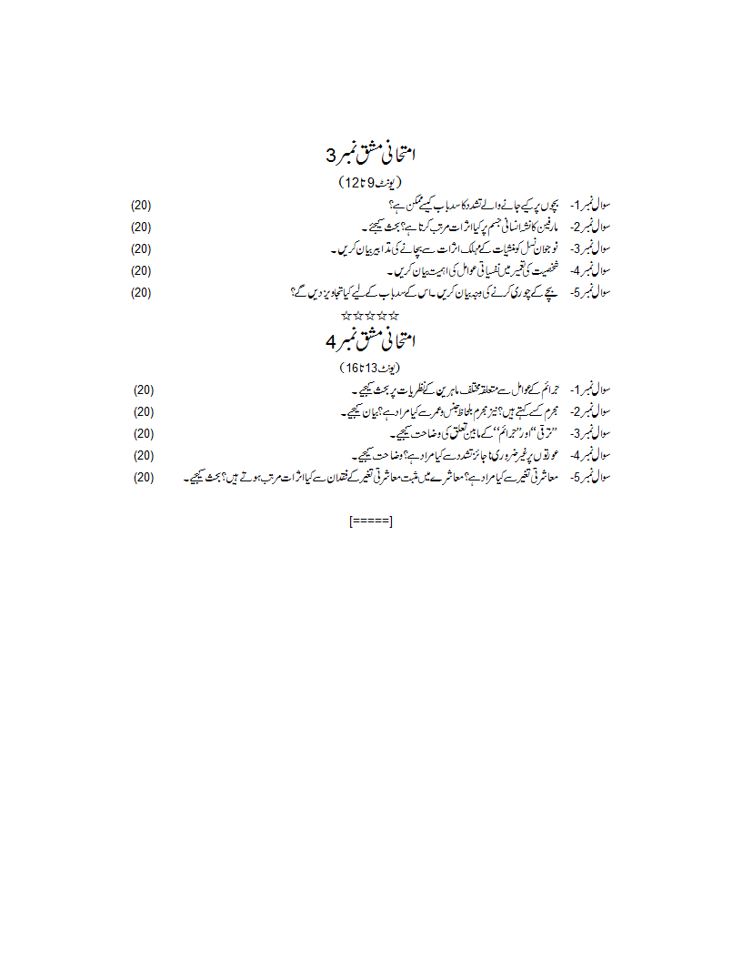
www.aioucheats.com Free solved assignments and old papers of Allama Iqbal OpenUniversity - AIOU

